Tagline:

This is a good example of a tagline because it explains well what the product does. It can help a customer quickly recognize whether or not this product is something their company needs to assure quality in their product without having to know how it does it.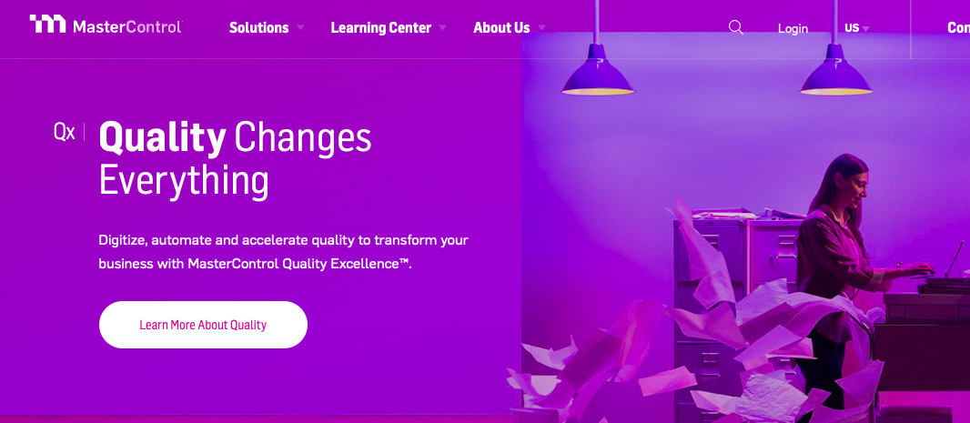

Dark Mode:

This is the first thing I thought of when I heard dark mode. By changing the setting to dark mode, it makes it way easier to read at night and it is super easy on the eyes. It also helps my battery not drain as fast when I am trying to read my scriptures after using my phone all day as well.

